Chapter 2 Motion in a gravitational field
Chapter Test Total marks 48
Name: __________________________ Class: ______ Date: ______
A data sheet with appropriate physics constants will be provided for this test.
Question 1
- The diagram below shows the path travelled by a soccer ball kicked from rest on the ground. On the diagram below, draw the vectors to represent the vertical, horizontal and resultant velocity at points A and B. The initial vectors are shown for reference. (5 marks)

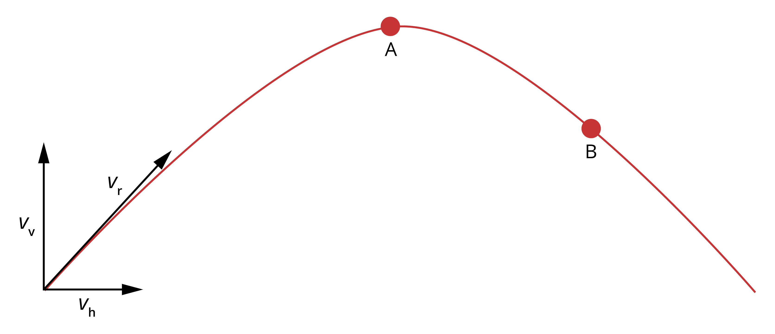

- The diagram below shows the path travelled by a shot-put, from A to D, after it has been thrown by a competitor from a height of 1.92 m.

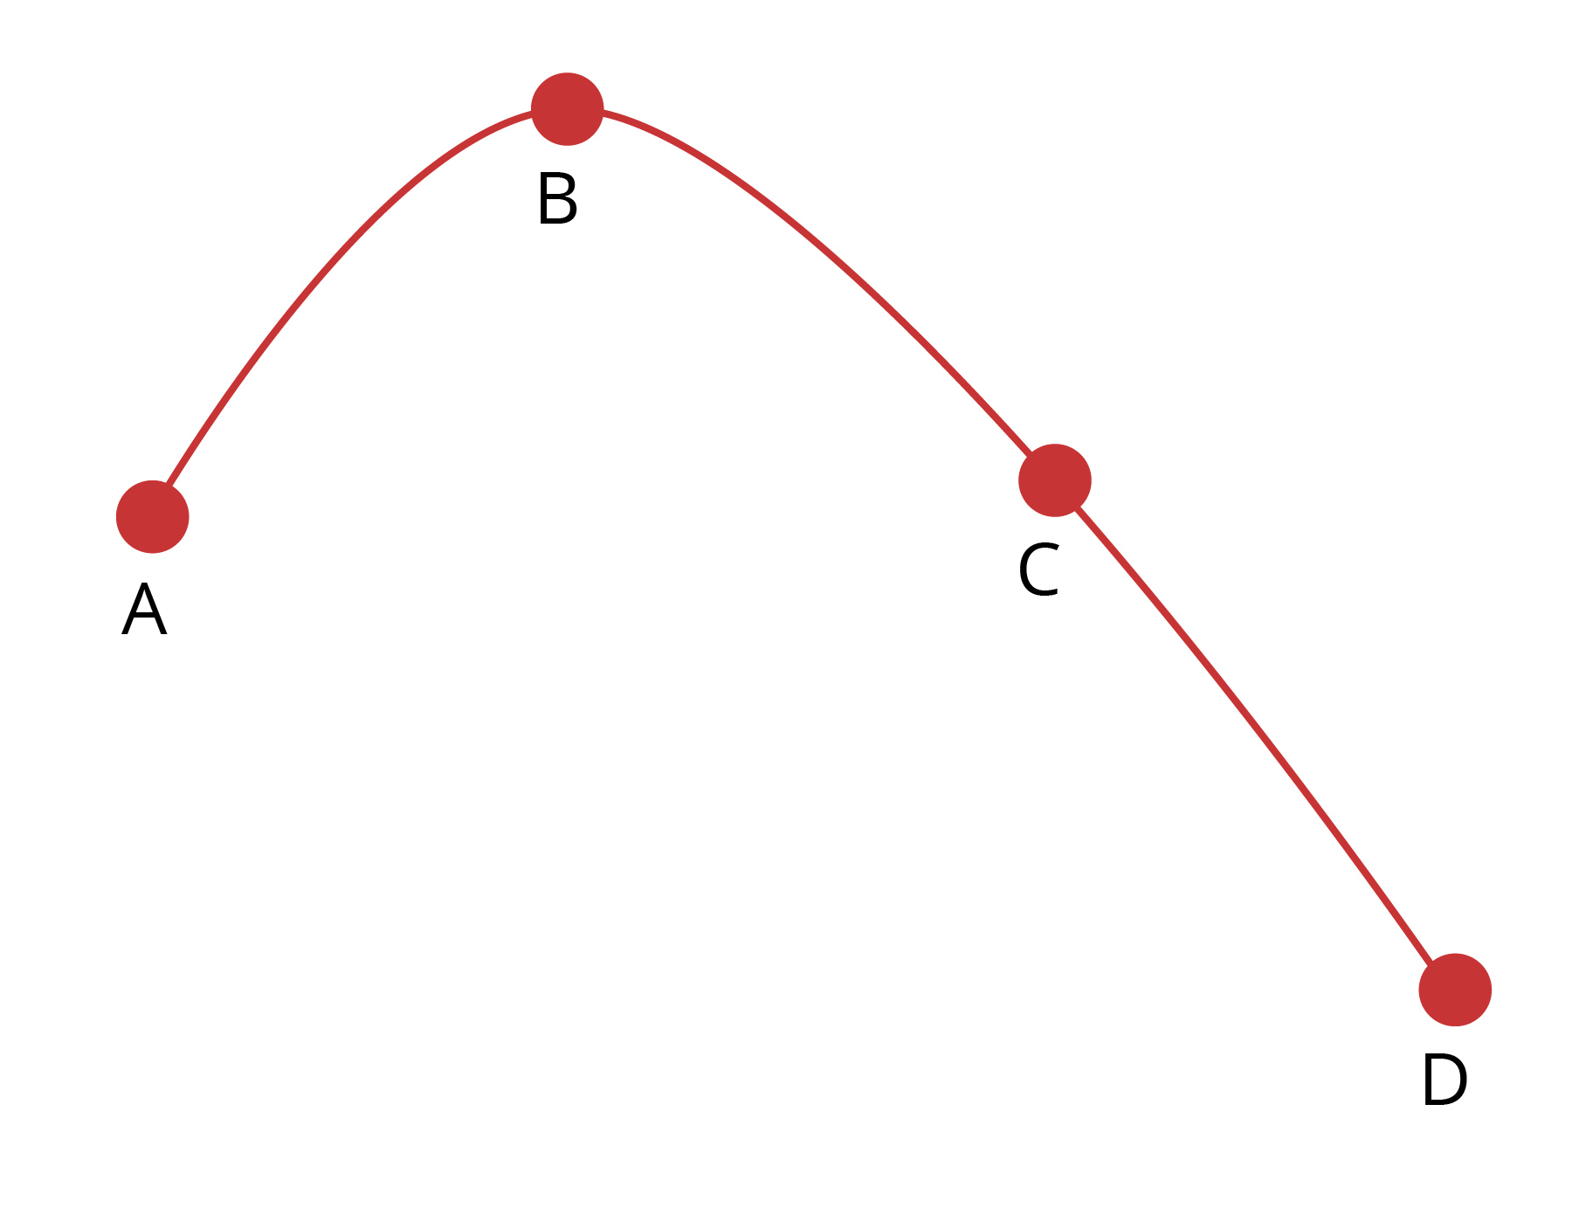

On the axes below, sketch the vertical component of velocity against time as it travels from the competitor’s hand until it strikes the ground. On your graph mark the points A, B, C and D that correspond to these points on the curve. Other labels can be used to assist if needed. (4 marks)
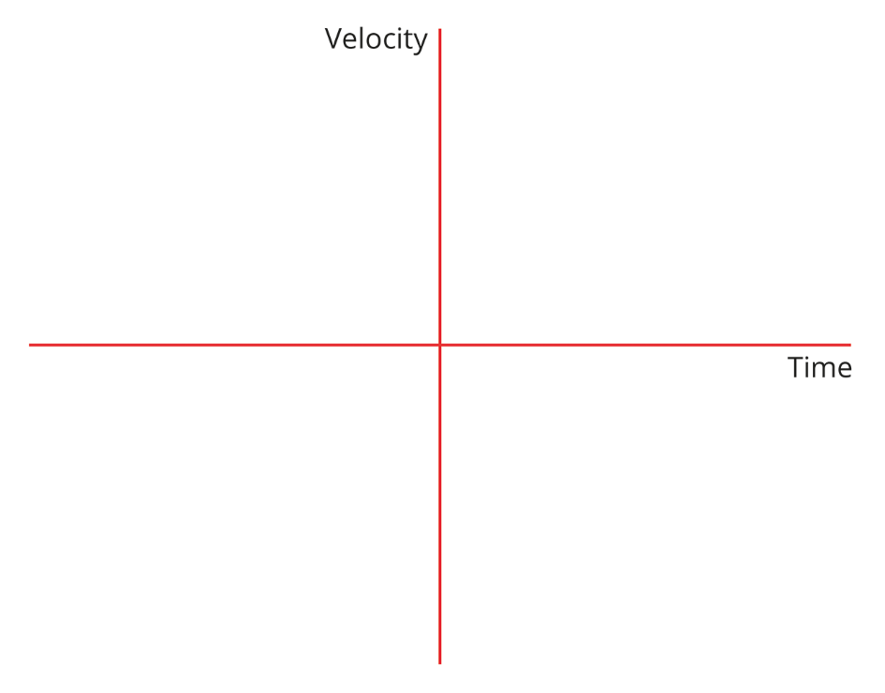

Question 2
At the Australia Day fireworks in Perth, a firework rocket is launched at an angle of 85° to the horizontal.
- At what initial velocity at the stated angle does the rocket need to be fired to reach a maximum height of 750 m if it starts from the ground? (4 marks)

- The firework technician needs to set the timer for the explosion so that it will explode at the maximum height. For how long must set the timer be set? (2 marks)

Question 3
The radius of a curved section of road is 35 m. At what angle should the road be banked to allow drivers to safely take the curve at the speed limit of 80 km h⁻¹ without needing to rely on the friction between the road and tyres?
Draw a labelled diagram to show the forces involved. (5 marks)

Question 4
The figure below shows a section of a roller-coaster ride.
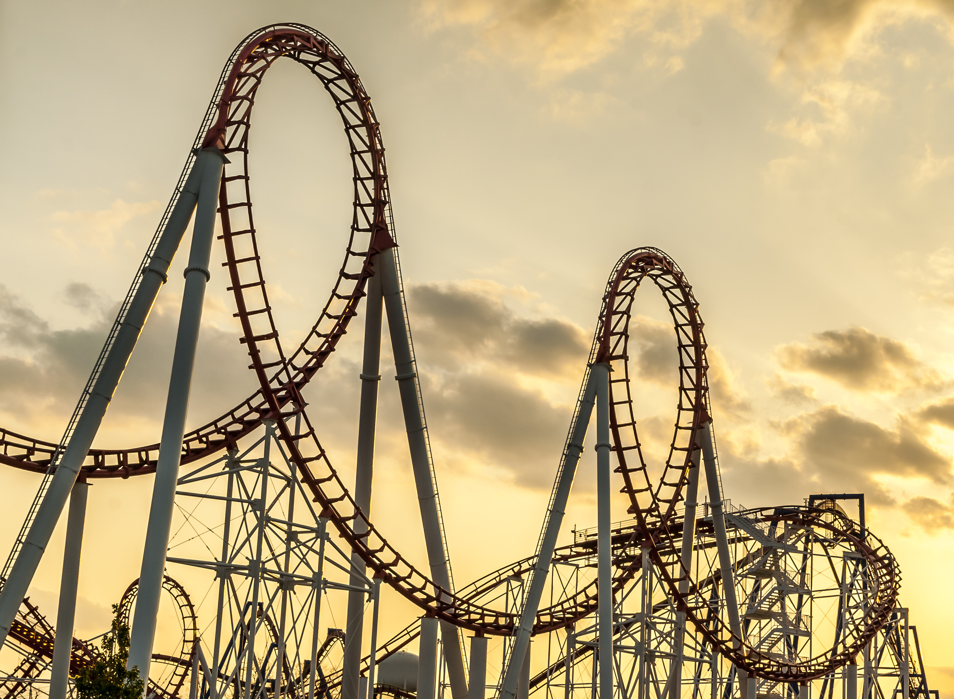
Source: Bastos/Fotolia.com

On the diagram, label the following.
- The position where a rider’s apparent weight will be greater than their actual weight as A. Explain why their apparent weight is greater at the position you have labelled.
(3 marks)

- The position where a rider’s apparent weight will be less than their actual weight as B. Explain why their apparent weight is less at the position you have labelled. (3 marks)

- The position where a rider’s apparent weight will be the same as their actual weight as C. Explain why their apparent and actual weights are the same at the position you have labelled. (3 marks)

Question 5
- Satellites (natural and artificial) do not require propulsion from a rocket or any other source to maintain their orbit. What is the force acting on a satellite to keep it in motion? (1 mark)

- Although artificial satellites require no propulsion to maintain their orbit, they are often equipped with a tank of propellant to make small corrections in their direction. Explain why, when a correction to their path is needed, the propellant will be ejected in the opposite direction to which the satellite needs to be corrected. (2 marks)

- If a satellite was placed in orbit around the Earth at an altitude of less than approximately 150 km, it would not remain in orbit even if its initial velocity was that required to give stable orbit at 150 km. Explain why this is so. (2 marks)

- A global positioning system satellite is to be placed at an orbit around the Earth with radius 21 800 km. At what velocity should the satellite be moving in its orbit?
(5 marks)

Question 6
- Astronomers investigating a newly observed planet and its moon determine the period of the moon to be 78.6 days and its radius of orbit to be 5.86 × 10⁸ km. Calculate an estimate for the mass of the planet’s moon. (4 marks)

- Determine the velocity with which the moon orbits the planet. (2 marks)

- Determine the mass of the planet. (3 marks)

